While there's nothing wrong with roses or chocolate, there's no better way to say "I love you" than by showing some love to the true number one - you. This Valentine's Day, complement yourself in something subtle yet special with Understatement Lingerie, making a statement that's anything but...

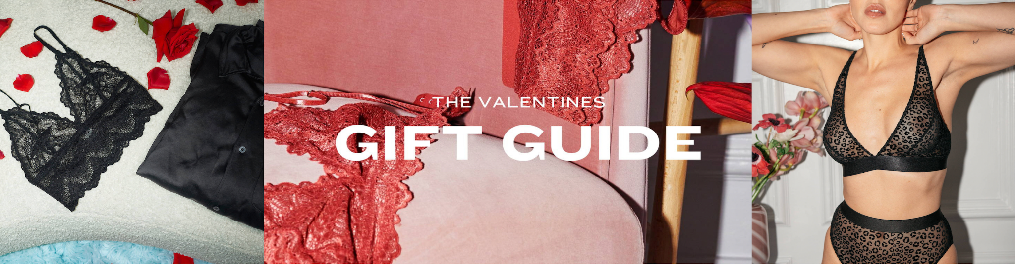

Whether you're The Tough Lover, Classy & Sassy, Soft Hearted or Slowing Down for a cozy-night in, Understatement's Valentine's Day styles ensure the love you spread this February 14th is endless - for that special someone or the most important and deserving person in your life...you. Understatement has you covered, no matter your style:

The Tough Lover
She demands timeless styles with edgy details highlighting that fierce personality.
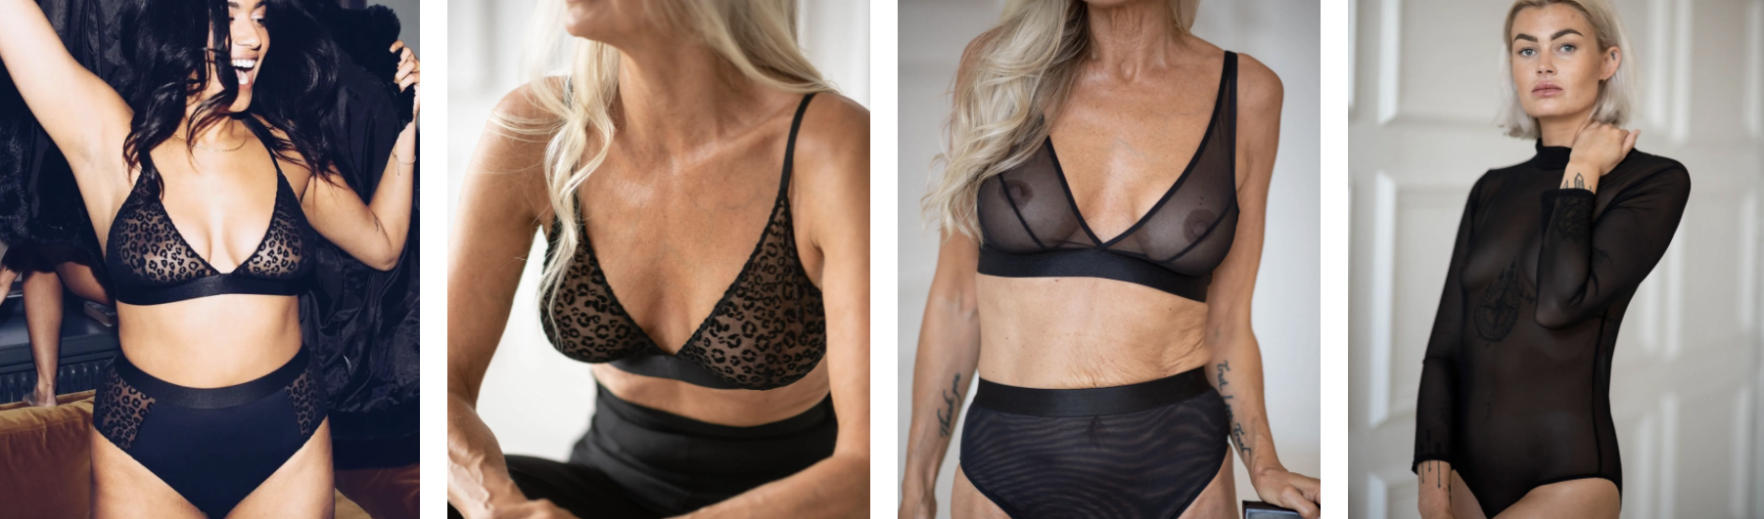

The Classy & Sassy
There’s a reason why classics never go out of style; and neither does she.
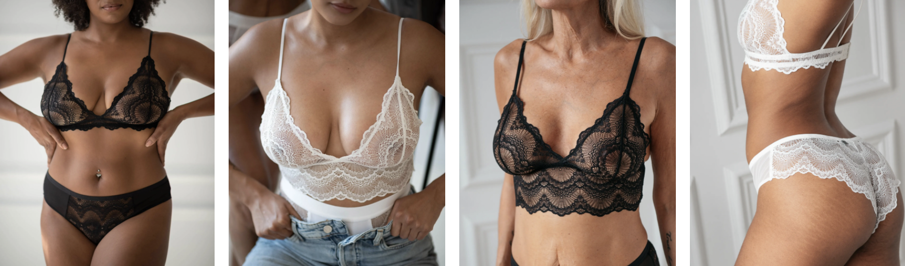

The Soft Hearted
Romantic styles in a perfect blend of comfort and style – all made in our finest recycled materials.
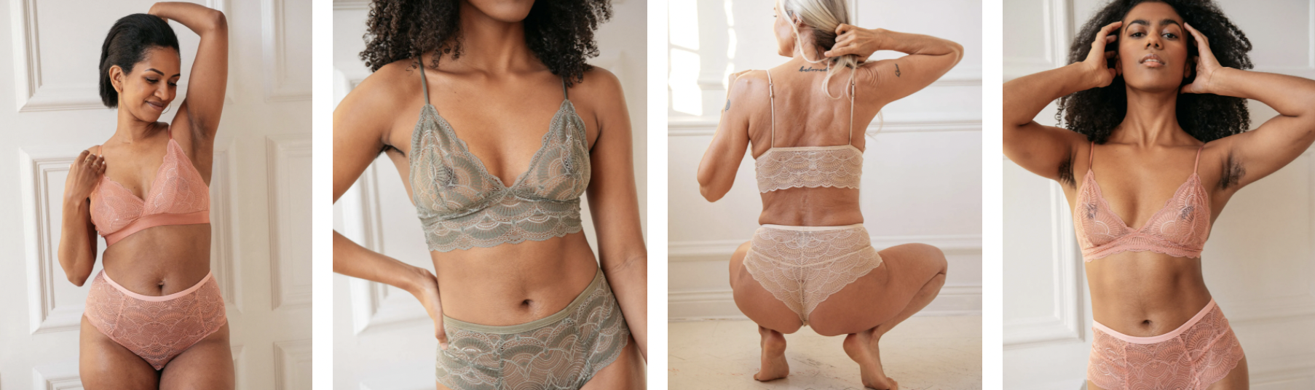

The Slow Down
Jump into our most comfortable yet flattering styles for a cozy night in.
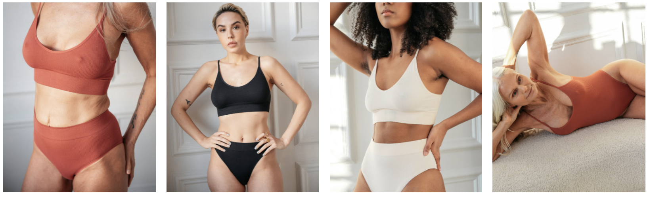

Making its debut in the US market, Understatement was founded in 2017 by Marie Stolt and Maria Lager to rethink the world of underwear, from the inside out. With a diverse range of bralettes, panties, swimwear and leisurewear to choose from, each Understatement product is made with comfort at its core and designed to make every body feel beautiful. Marie and Maria carefully handpick each material to create undergarments that feel as good as they look, while seeking and selecting new fabrics and technologies that are kinder to both the planet and your skin.

Should Understatement be a fit for any upcoming projects or stories you're working on, please let us know and we'd be happy to make samples and/or imagery available!

Fayra Molina, Associate
EightSixtySouth
Los Angeles - New York

(she/her/hers/ella)
fayra@eightsixtysouth.com
o. 213-407-5766
m. 717-419-2007
eightsixtysouth.com
@eightsixtysouth

